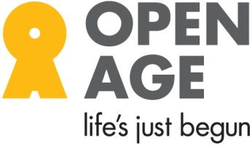
Open Age Volunteer Application Form

Registered Charity No. 1160125
Open Age, St. Charles Centre for Health & Wellbeing
Exmoor Street, London, W10 6DZ
020 4516 9978 www.openage.org.uk

Surname:

Forenames:

Address:

Telephone - Home: __________________Mobile: __________________

E Mail _______________________________

How do you prefer to be contacted?
Home phone Mobile Email No Preference

How did you hear about us? ______________________________________________

For more information about how we process and retain your data please email: Mail@openage.org.uk
Please state why you would like to volunteer with Open Age:

If you have any qualifications, training and/or previous work experience (this could be volunteer work or paid employment) please describe briefly.

What days/hours are you available to volunteer?

Please tick what type of volunteer work you are most interested in:
Be Active Programme (see below)
Reception (answering phone, welcoming visitors, giving information)
IT training support
Supporting activity sessions
Teaching sessions/sharing a hobby interest
Admin support
Delivering/posting publicity
Data entry
Other (please indicate)

Be Active Programme
The Be Active Programme is a 9-12 week programme to support a 60+ person’s mobility through encouraging them to meet their activity goals and prescribed exercises; training is included.

This programme may take place in and around the person’s home. Please indicate below which areas you would be able to volunteer in (tick as many as apply):

North Kensington (e.g. Ladbroke Grove, Notting Hill, etc.)
Central & South Kensington (including Earl’s Court)
Chelsea
North Westminster (e.g. Queen’s Park, Westbourne, Paddington, etc.)
South Westminster (e.g. Pimlico, Westminster, etc.)
No preference – can go anywhere

Please give the name and address of two people who will act as a referee for you (The referees should not be relatives.)

Name: Name:

Relationship to you: Relationship to you:

Email: Email:

Address: Address:

Telephone: Telephone:

Signature Date:

Return to: Open Age, St Charles Centre for Health & Wellbeing, Exmoor St, London, W10 6DZ or via email to: mail@openage.org.uk

